PRESIDENT’S OFFICE
REGIONAL ADMINISTRATION AND LOCAL GORVEMENT
FORM IV TAHOSSA NORTHWESTERN ZONE MOCK EXAMINATION 2025

041 BASIC MATHEMATICS

TIME 3:00HRS AUGUST 2025

INSTRUCTIONS
- This paper will consist of sections A and B with a total of 14 questions
- Answer all questions in both sections A and B
- Section A will carry 60 marks and section B will carry 40 marks
- Mathematics tables /Calculator may be used
- Write your Examination number on the top right corner of your answer booklet provided
- Use R = 6400 and

SECTION A (60 MARKS)
- (a) Write a number in which 0 represents hundreds, 7 represents ten thousand, 3
represents ones, 9 represents thousands, 6 represents hundred thousand and 8 represents tens.
(b) Convert 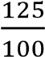 and 360% to decimal, then approximate their products to one
significant figure.
(C) 14 − [−2 − (8 ÷ 2) + 5]
- (a) If log 2 = 0.3010, Find the value of log 5, without using mathematical table
(b)If 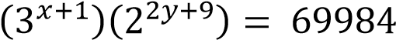find the values of x and y.
(c)Simplify by rationalizing the denominator of 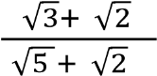
- (a) A bag contains 5 red and 4 blue balls. Two balls are drawn in succession without
replacement. Find the probability that both are red.
(b) In a class of 35 students, 19 take physics, 18 take History and 3 take neither of the two subjects. Calculate how many students take
- Both subjects
- Physics or History

- (a) Find the equation of a line passes through the point of intersection of the lines 3x −2y−8=0 and 2x+y =3 and is perpendicular to line 4x +3y=0

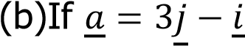 and 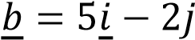 and 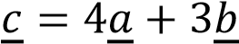 find

            - Magnitude of 𝑐
            - Direction of 𝑐

- (a) The area of the triangle ABC is 140 cm² ,side AB = 20 cm, AC is 14 cm. Find the
angle BAC
(b)From the Rectangle JKLM given below
- Name two triangles which are congruent
- Prove your answer in (i) above
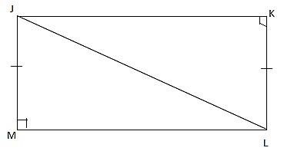
- (a) Given that (Z + 1) is directly proportional to x and inversely proportional to the
square root of y. If x =2 when y=4 and Z =4 find Z when X = 3 and y =9 (b) A bus travels 240 km using 16 litres of diesel. How many liters of diesel areneeded to drive 90km?

- (a) On January 1st 2015 MTL group started a business with a capital in cash of
2,000,000/=
January 2. Purchased goods for cash 1,400,000/=
3. Sold good for cash 1,000,000/=
6. Purchased goods for cash 60,000/=
15. Paid rent for cash 220,000/=
26. Sold goods for cash 620,000/=
Prepare the cash account and balance it
(b) If the ratio of sacks of maize, millet and cassava in certain store is 6:7:3. There are 42 sacks of millet. Find the total sacks in a store.

- (a) If the common difference of an A. P is −2 and the third term is 0. Find
  - The first term
  - The general term
(b)A certain geometric progression has a common ratio of 2 and the sum of the first ten terms is 155. Find the first term and give the formula for the n^{th} term

- (a) Without using tables, find the value of 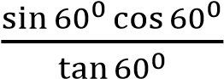and simplify your answer.
(b)The sides of a right angled Triangle are (2𝑥 + 1) 𝑐𝑚, (12𝑥) 𝑐𝑚 and (12𝑥 + 1) 𝑐𝑚. Find the value of x in cm if the hypotenuse is (12𝑥 + 1) cm

- (a) Use factorization method to find the value of x if 8𝑥² − 34𝑥 + 21 = 0
(b)The average of two numbers is 7 and three times the difference between them is 18. Find the two numbers

SECTION B (40 MARKS)
- (a) These scores of Mathematics Examinations done by 60 students were recover as follows
36, 26, 52, 54, 51, 34, 26, 29, 34, 26, 30, 56, 21, 49, 35, 58 22,
38, 28, 26, 41, 53, 31, 32, 20, 21, 61, 58, 36, 50, 56, 63 27, 30,
63, 30, 60, 34, 48, 28, 41, 57, 24, 35, 35, 33, 20, 59
36, 25, 32, 43, 56, 30, 50, 42, 21, 33, 45, 25
- Prepare frequency distribution table using intervals 20−24,25−29, 30−34
- Calculate mode and Median
(b)Find the value of angle x, in the figure below
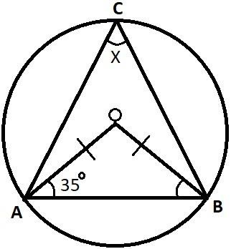

- (a) The figure below shows a rectangular prism in which AB= 10cm, BC= 8cm and GC = 6cm

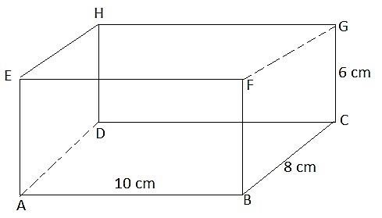
        - Calculate the length AG (Two decimal places)
        - The angle that AG makes with the plane ABCD
  - A and B are two points on latitude 70°N. Their longitudes are 62°W and 118°E respectively. Calculate the distance in kilometers from A to B if the Earth’s diameter is 12,800km along a parallel of latitude

- (a) Think of two numbers. If I double the first and add the second I get 18. If I double
the first and subtract the second I get 14. Use matrix method to find the two numbers
(b) Find the value of “t” given that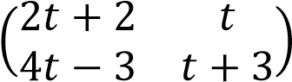 is a singular matrix.
(c) Find the image equation of the line y = 3x + 7 after reflection is the line y=x 14.
- (a) Maximize f(x, y) = 2x + 6y subject to the following constraints
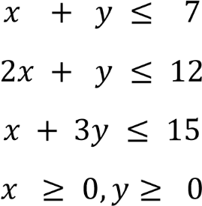
𝑥 𝑖𝑓 𝑥 < −2
(b) The function f(x) defined as 𝑓(𝑥) = {2𝑥 𝑖𝑓 − 2 ≤ 𝑥 < 3
𝑥 + 1 𝑖𝑓 𝑥 ≥ 3
- Sketch the graph of f(x)
- State domain and range of f(x)

